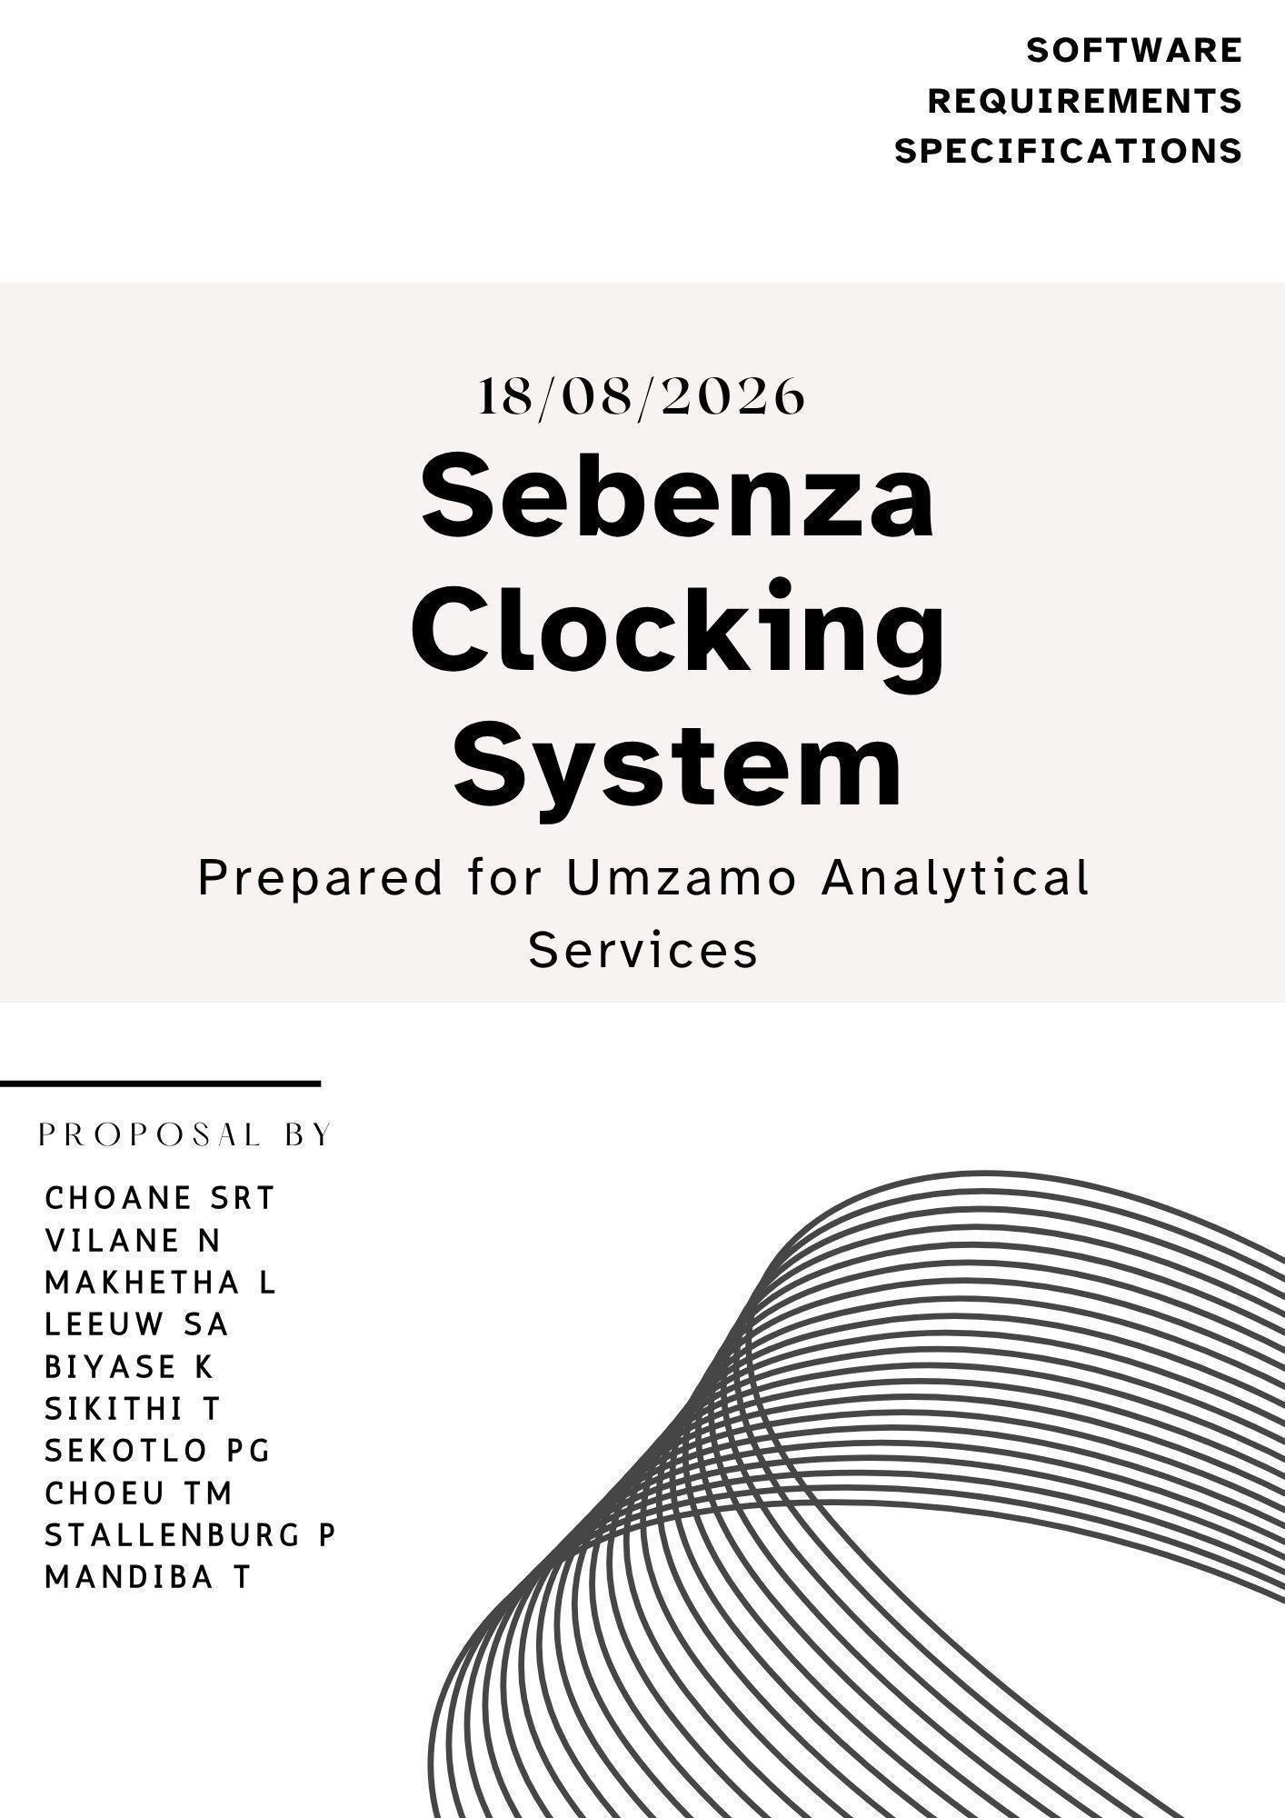

PROJECT INTRODUCTION ........................................................................................................4
1.1 ORGANISATION AND STAKEHOLDERS
.............................................................................4
1.2 Current Process and People Involved
...................................................................................6
1.2.1 Current Process diagram
.................................................................................................7
Effected Users; ......................................................................................................................8 1.4
Problem Experienced and its Consequence........................................................................10
1.5 Project Aim and Objectives ..................................................................................................
11
1.6 Project
Scope........................................................................................................................12
Deliverables and acceptance criteria
.........................................................................................13
1.8 Requirements Prioritisation
..................................................................................................14
1.9 Stakeholder Needs
...............................................................................................................16
1.11 Non- Functional Requirements
...........................................................................................18
1.12 System Requirements
........................................................................................................19
1.13 Integration Requirements
...................................................................................................20
1.14 Requirements change log
..................................................................................................20
1.15 Refined Project Scope
........................................................................................................21
1.16 Feasibility Study
..................................................................................................................22
1.17 Project Risk Register
..........................................................................................................23
Three Identified as Highest Risk .............................................................................................25 Supabase Screenshot
.............................................................................................................26 SEBENZA CLOCKING SYSTEM ...............................................................................................26
- New chapter: System Architecture and Design
.....................................................................33
  - Introduction to System Design
.............................................................................................33
  - System Architecture
..............................................................................................................34
    - Architecture overview
........................................................................................................34
    - Architecture components and responsibilities
..................................................................35
    - How the components work together
.................................................................................36
    - Architecture design decisions
............................................................................................36
    - The main data flow
............................................................................................................37
2.3.1 Use Case Diagram Overview
............................................................................................38
  - Sequence Diagram — Employee Clock-In
..........................................................................40
    - Employee Clock In Overview
............................................................................................40
Explanation
........................................................................................................................41
  - Sequence Diagram — Overtime
..........................................................................................42
    - Overtime Sequence Diagram — Overview
.......................................................................42
- DATABASE DESIGN: ENTITY RELATIONSHIP DIAGRAM (ERD) ......................................44
2.6.3 Entity and Attributes table
..................................................................................................45
- USER INTERFACE DESIGN AND DESIGN ALIGNMENT ...................................................48 main Flutter mobile screens
....................................................................................................48 How users navigate between important flutter screens .............................................................51 main ASP.NET web pages ..........................................................................................................52
How users navigate between important ASP.NET screens .......................................................56

PROJECT INTRODUCTION

Sebenza Clocking System is a proposed employee attendance and working-hours management system for Umzamo Analytical Services, a coal laboratory.
The project was identified from an existing attendance-management process in which employees manually record their clock-in and clock-out times and working hours using paper-based forms.
The current process relies on employees entering their own attendance information. According to the initial information provided by the stakeholder, there are situations where employees arrive late but record their normal expected starting time. There are also situations where overtime is recorded even though the employee did not work overtime.
This creates a need for a more reliable method of recording employee attendance and working hours.
The proposed Sebenza Clocking System will investigate and provide a digital method for recording employee clock-in and clock-out events using automatically generated timestamps. The system will also investigate an appropriate process for managing and verifying overtime.
The proposed solution will consist of a Flutter mobile application, an ASP.NET web application and a shared Supabase backend.
The project will be developed according to stakeholder requirements gathered from Umzamo Analytical Services.

PHASE 1: PLANNING, REQUIREMENTS AND FEASIBILITY

1. STAKEHOLDER AND PROBLEM ANALYSIS

1.1 ORGANISATION AND STAKEHOLDERS

Organisation: Umzamo Analytical Services.

Industry: Coal Mining Laboratory.

Primary Project Problem: Manual employee attendance and working-hour recording.

Proposed System: Sebenza Clocking System

Umzamo Analytical Services is the external stakeholder organisation for this project.
The organisation has been selected because its current employee attendance process is manually managed and relies on employees recording their own attendance and working-hour information on paper.

Stakeholder | Role
Employees | Record their attendance and working hours
Supervisors/Management | Monitor and verify employees’ attendance and working hours
Human Resources | Manage attendance records
Finance | Use approved working-hours and overtime information
Project Team | Investigate, design, develop and test the proposed system

1.2 Current Process and People Involved

The current clocking in & out process is paper/manual based

The initial process is identified as follows:
- Employee arrives at work
- Employee manually fills in their arrival time on a paper attendance form
- Employee performs their normal work
- Employee manually records their departure time
- Employee records hours worked
- If overtime is worked, the employee records the overtime information
- Attendance forms are used by the organisation to monitor employee attendance and working hours
- The organisation relies on recorded information when reviewing attendance and overtime

1.2.1 Current Process diagram
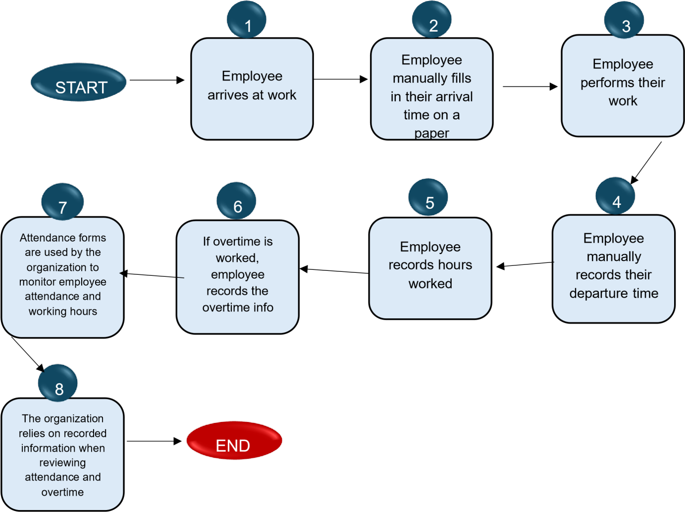

1.3 Problem Statement and Affected Users:
Umzamo Analytical Services currently uses a manual paper-based process for recording employee attendance and working hours. Employees manually record their clock-in and clock-out times and may also record overtime.
The current process relies on self-reported information and does not automatically verify the actual time at which an employee arrives at or leaves the workplace. The stakeholder has identified instances where employees arrive late but record their normal starting time and instances where overtime is recorded even though overtime was not worked.
As a result, the organisation faces a risk of inaccurate attendance and working-hour records and may have trouble verifying the accuracy of recorded overtime.
A digital attendance management system is therefore required to investigate whether employee attendance can be recorded using automatically generated timestamps and whether overtime can be managed through a more controlled and verifiable process.
Effected Users;
- Employees: Employees are directly affected because they currently use paper forms to record their attendance and working hours.
- Management: Management may require attendance information to monitor employee attendance and working hours.
- Payroll/Finance: Payroll or finance personnel may use approved working-hour or overtime information if confirmed by the stakeholder.
- Administration: Administrative personnel may be responsible for managing employee attendance information.

1.4 Problem Experienced and its Consequence

The primary problem identified is that employees’ attendance, working hours and overtime hours are manually recorded by employees

The Stakeholder has indicated that:
- Employees arrive late but record their normal starting time
- Employees take longer lunch breaks
- Employees may record overtime that was not actually worked
•
- The paper-based process does not automatically capture the actual hours worked and actual time at which an employee clocks in or out
- Attendance and overtime information therefore requires manual recording and verification

These consequences were confirmed by the organisation’s stakeholders during the requirements investigation

Consequences of the Current problem:
✦ Inaccurate attendance records
- Difficulty verifying actual arrival time
- Difficulty verifying actual departure time
- Inaccurate working-hour information
- Incorrect overtime information • Additional administrative work
✦ Difficulty maintaining reliable historical attendance records

1.5 Project Aim and Objectives

AIM:
The aim of the Sebenza Clocking System project is to develop an prototype digital employee attendance and working-hours management system for Umzamo Analytical Services that provides a more reliable and verifiable method of recording employee clock-in, clock-out and overtime information

OBJECTIVES:
Investigate Umzamo Analytical Services existing attendance process o
Identify problems associated with manual attendance recording o Identify the needs of employees, supervisors and management o Define a functional and non-functional system requirements o Design a realistic employee attendance management solution o Develop a Flutter mobile application for employee attendance function o Develop an ASP.NET application/API for backend and administrative functions Use Supabase as the shared database/backend o Automatically record clock-in and clock-out timestamps o Calculate working hours from recorded attendance data o Provide appropriate attendance reports Test the system against confirmed stakeholder requirements o Evaluate whether the proposed system addresses the identified problem

1.6 Project Scope

Employee  Functions | Management  Functions | Administration  Functions | System Functions
o Employee  clock-in | o View employee  attendance | o Manage  employee  account | o Role based access
o Employee  clock-out | o Search attendance records | o Manage attendance records | o Automatic timestamp generation
o Automated timestamp  recording | o Filter  attendance records | o Handle attendance corrections | o Working hours  calculation
o View current attendance status | o Monitor attendance | o Generate attendance  reports | o Attendance record storage
o View attendance  history | o Review overtime |  | o Overtime management
o View recorded working hours | o Approve or  reject  overtime |  | o Audit  information for changes

The project may be constrained by: o Available semester time o Group members technical skills o Stakeholder availability o
Academic assessment deadlines

Project Assumptions:
Stakeholders will provide information about the existing attendance process
The organisation has a defined method of identifying employees o
The group can obtain sufficient technical knowledge to use Flutter,
ASP.NET and Supabase o The prototype will not process actual salary payments o The organisation will provide feedback on the proposed solution

Deliverables and acceptance criteria

Deliverable | Acceptance criteria
Flutter mobile application | Employees can successfully log in, clock in and clock out
ASP.NET backend | API successfully processes and validates attendance requests
Supabase | Attendance records stored correctly
Attendance management | Authorised users can view attendance history
Reports | Overtime can be recorded and managed according to approved rules

1.8 Requirements Prioritisation

Requirements | Priority
User authentication | Must have
Employee Clock-In | Must have
Automatic Clock- In timestamp | Must have
Employee Clock-Out | Must have

Automatic Clock-out timestamp | Must have

Attendance history | Must have
Working- hour calculations | Must have

Management attendance  monitoring | Must have
Overtime management | Must have
Employee management | Must have
Break recording | Must have
Audit Logging | Should have
Attendance corrections | Should Have
Reporting | Must have

1.9 Stakeholder Needs

Employees | Management | Administration | Finance
Simple clock-in and  clock-out process | Reliable  Attendance  information | Centralised  attendance records | Accurate working-hour information for payroll use
Ability to view their attendance | Attendance  reports | Reduced reliance on paper forms
 |  | Reliable attendance information

1.10 Functional Requirements:

ID | Functional Requirements
FR1 | The system must allow authorised users to securely log into the system.
FR2 | The system must allow an authenticated employee to clock in.
FR3 | The system must automatically record the date and time when the employee clocks in.
FR4 | The system must allow an authenticated employee to clock out.
FR5 | The system must automatically record the date and time when the employee clocks out.
FR6 | The system must allow employees to view their recorded attendance history.

FR7 | The system must calculate working hours using the recorded clock-in and clock-out timestamps, deducting approved break time where applicable.

FR8 | Authorised supervisors and management users must be able to view employee attendance records.
FR9 | The system must provide a mechanism for recording and managing overtime.

FR10 | Authorised administrators must be able to manage employee information.
FR11 | the system must allow employees to submit attendance correction requests.
FR12 | The system must allow authorised users to generate and export attendance and overtime reports.
FR13 | The system must record audit information for changes made to attendance, overtime, and employee records.
FR14 | The system must allow employees to record break periods during their shift

1.11 Non- Functional Requirements
ID | Non-Functional Requirements
NFR1 | The system should be simple and intuitive so that employees can clock in and out with minimal interaction
NFR2 | The system should process normal clock-in and clock-out requests within an acceptable response time under normal operating conditions
NFR3 | Only authorised users should be able to access employee attendance information
NFR4 | Employee information and attendance records must be protected from unauthorised access
NFR5 | The system should be reliable to store clock-in and clock-out information
NFR6 | The system should be available all the time especially during working hours
NFR7 | The system must maintain a tamper-evident audit trail of all changes made to attendance, overtime, and employee records

1.12 System Requirements

User Requirements | Software | Hardware
o Employee account | o Flutter mobile application | o Android smartphone  /device for employees
o Management /admin account | o ASP.NET backend/API | o Computer for  management and  administration
o Appropriate authentication credentials | o Supabase database/backend | o Internet/network  connection
o Supported web browser for management
functions

1.13 Integration Requirements
The Sebenza Clocking System will integrate these three main technologies 1.
Flutter: Flutter will be used to develop the employee mobile application/ system. The application will communicate with the backend to, o
Authenticate users o Submit clocking- in events o Submit clocking- out events o Retrieve attendance information o Display working hours and overtime hours

- ASP.NET: ASP.NET will provide the server-side applications/ API. The asp.net component will, o Process requests from the Flutter application o Apply business rules o Validate attendance information o Manage authentications o
Communicate with supabase Provide necessary attendance and overtime information

- Supabase: Supabase will provide the shared backend which will contain relevant information such as, o Users o Employees o Departments o Attendance o Overtime
Attendance corrections

1.14 Requirements change log

Version | Requirement  Changes | Reason | Date
01 | Initial Sebenza Clocking System concept | Identified manual attendance process | 18 August 2026
02 | Automatic clock-in timestamps added | Stakeholders  identified inaccurate  manual clock-in  times | 22 August 2026
03 | Automatic clock-out timestamps added | Improved reliability of  recorded clockout  times | 22 August 2026
04 | Overtime approval process proposed | Stakeholders identified inaccurate overtime records | 29 August 2026
05 | attendance corrections, reporting, audit logging, break recording | Identified during  Phase 2 design these features appear in the UI and ERD but were  not formally specified  in  Phase 1 | 25 September  2026

1.15 Refined Project Scope

Following the initial stakeholder investigation, the refined project scope is centered on creating a digital attendance system that records employee clock-in and clock-out events using automatically generated timestamps

The project will not initially include payroll processing, biometric hardware, facial recognition or external payroll integration.

The core system will include:
Clock-in o Clock-out o Automatic timestamps o Attendance history o Working hours calculations o Attendance monitoring o Overtime management o Attendance
Basic reporting

1.16 Feasibility Study

Technical Feasibility Area: The proposed system/ application will use
Flutter, ASP.NET and Supabase. Potential technical challenges include, o API development o Database design Flutter and
ASP.NET communication o Supabase configuration
Role-based access control

Operational Feasibility Area: This proposed system/ application will improve the reliability of attendance records by automatically recording clocking- in and clocking- out time. However, this feasibility will depend on, o The willingness of the employee to use the system o Management acceptance Workplace connectivity

Economic Feasibility Area: The proposed system doesn’t require any physical clocking hardware. Meanwhile potential costs may be, o Internet connectivity o Devices for developing the system o Future production deployment

Schedule Feasibility Area: The system must be developed within the semester. Therefore, the following core functions will be prioritized, o Clock- in o Clock-out o Attendance records o Working hours calculations o Overtime management o Reporting

Legal Feasibility Area: The system may process employee personal information and attendance information. Therefore, the system will consider the following, Privacy o Access control o Data protection o
Secure storage

Ethical Feasibility Area: Attendance information will affect employees so the system should, o Record information accurately o Preventing unauthorized modification o Provide an appropriate o Protect private employee information Overall Feasibility Decision: The Sebenza Clocking System is considered feasible as an academic prototype. The project will prioritise it’s core functionalities before considering additional features

1.17 Project Risk Register

Ri sk ID | Risk  Stateme  nt | Ratin  g | Impa  ct | Risk Leve  l | Mitigation | Contingen  cy | Risk  Owner | Risk Statu  s
Ri sk ID: 01 | Stakehol  der  becomes unavaila ble | 3-  Possi  ble | High | High | Schedule meetings early | Use remote communica  tion | Stakeho  lder | Open
Ri sk ID: 02 | Require ment  change  after  develop ment t begins | 4-  Likely | High | High | Confirm requiremen  ts early | Update requiremen  ts | Group member s | Open
Ri sk ID: 03 | Flutter and  ASP.NET integratio n problems | 4-  Likely | High | High | Test API early | Simplify integration | Group member  s | Open

Ri sk ID: 04 | Supabas  e  problems | 4-  Likely | Medi um | Medi  um | Develop supabase  early | Rebuild affected component  s | Group member  s | Open

Ri sk ID: 05 | System  records  incorrect  attendan ce | 3-  Possi  ble | High | High | Validate timestamps  and logic | Provide authorised correction process | Group member  s | Mitiga  ted

Ri sk ID: 06 | Develop ment  exceeds available  time | 4-  Likely | High | High | Monitor  Microsoft Project plan and  progress  tracker | Prioritise core MVP | Group member  s | Open
Ri sk ID  07 | Employe  e or  manage  ment have a difficult time adapting to new digital system | possi ble | high | high | Keep the interface simple, provide basic user guidance, and demonstrat  e the system  to stakeholder s before evaluation | Provide additional guidance, simplify the  interface where possible and collect user feedback. | Group member  s | open
Ri sk ID  08 | Attendan ce records  may be lost or become  unavaila ble  because  of a  database  or  backend failure. | possi  ble | High | High | Use Supabase's database features appropriatel y, test data storage/retr ieval, and maintain backups or recovery procedures where possible. | If  attendance data becomes unavailable  ,  investigate the database issue, restore available data from a backup/rec  overy point, and temporarily record attendance manually until the system is restored. | Group member  s | open

Three Identified as Highest Risk
Excessive Project Scope: The project might become too large if the team attempts to implement advanced features like biometrics, facial recognition and complex analytics Integration Problems: The system will require Flutter, ASP.NET and Supabase to communicate correctly
Unauthorised Access: Attendance information is potentially sensitive employee information

GitHub Repo Link: https://github.com/biyasekwanele/sebenza-clocking-system Supabase Screenshot
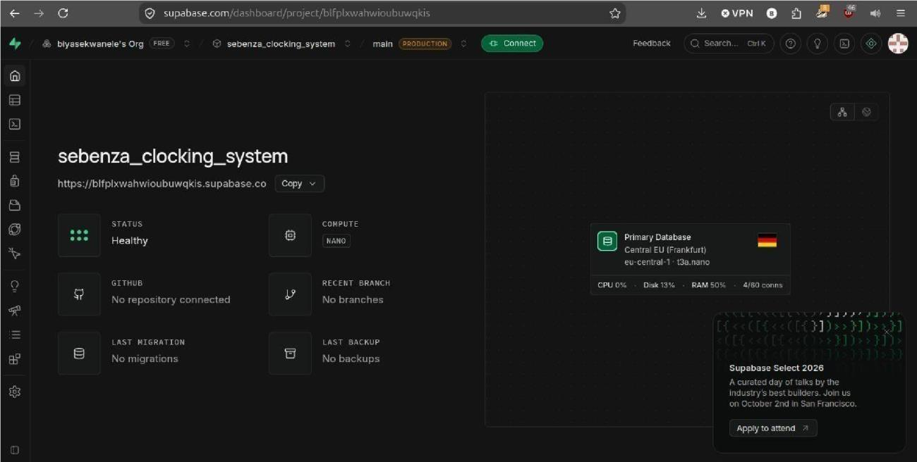

Supporting evidence

SEBENZA CLOCKING SYSTEM

Purpose of the interview
The purpose of this interview is to gather information from Umzamo Analytical Services about the current employee attendance and working hours process, the problems experienced with the existing manual paperbased system, and the requirements for the proposed Sebenza Clocking System.

STAKEHOLDER INTERVIEW QUESTIONS
- How do employees currently record their clock-in and clock-out times?
- How are attendance records stored and maintained?
- What are the main problems you experience with the current paper-based attendance system?
- Have there been situations where employees recorded an incorrect clock-in or clockout time?
- Should employees be able to view their attendance history?
- Should the system automatically record the exact date and time when an employee clocks in and out?
- How should the system calculate the total working hours from the clock-in and clockout times?
- What security measures should be used to protect employee attendance information?
- Who should be authorised to access employee attendance records?
- Would biometric or facial-recognition features be useful for the organisation in the future?
Figure 1 Interview Questions

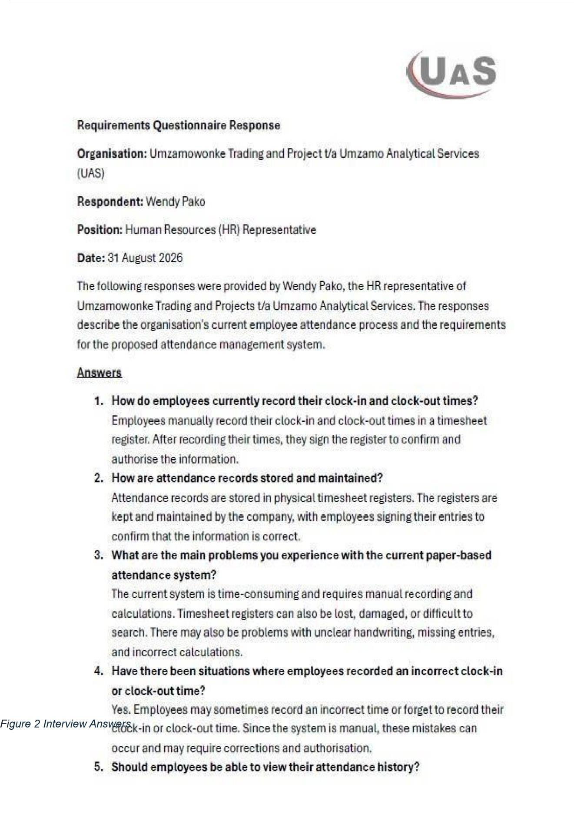

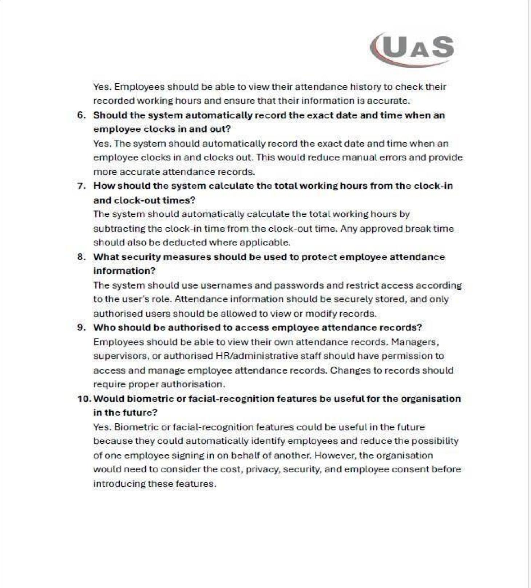
Figure 4 Continuation of Interview answers
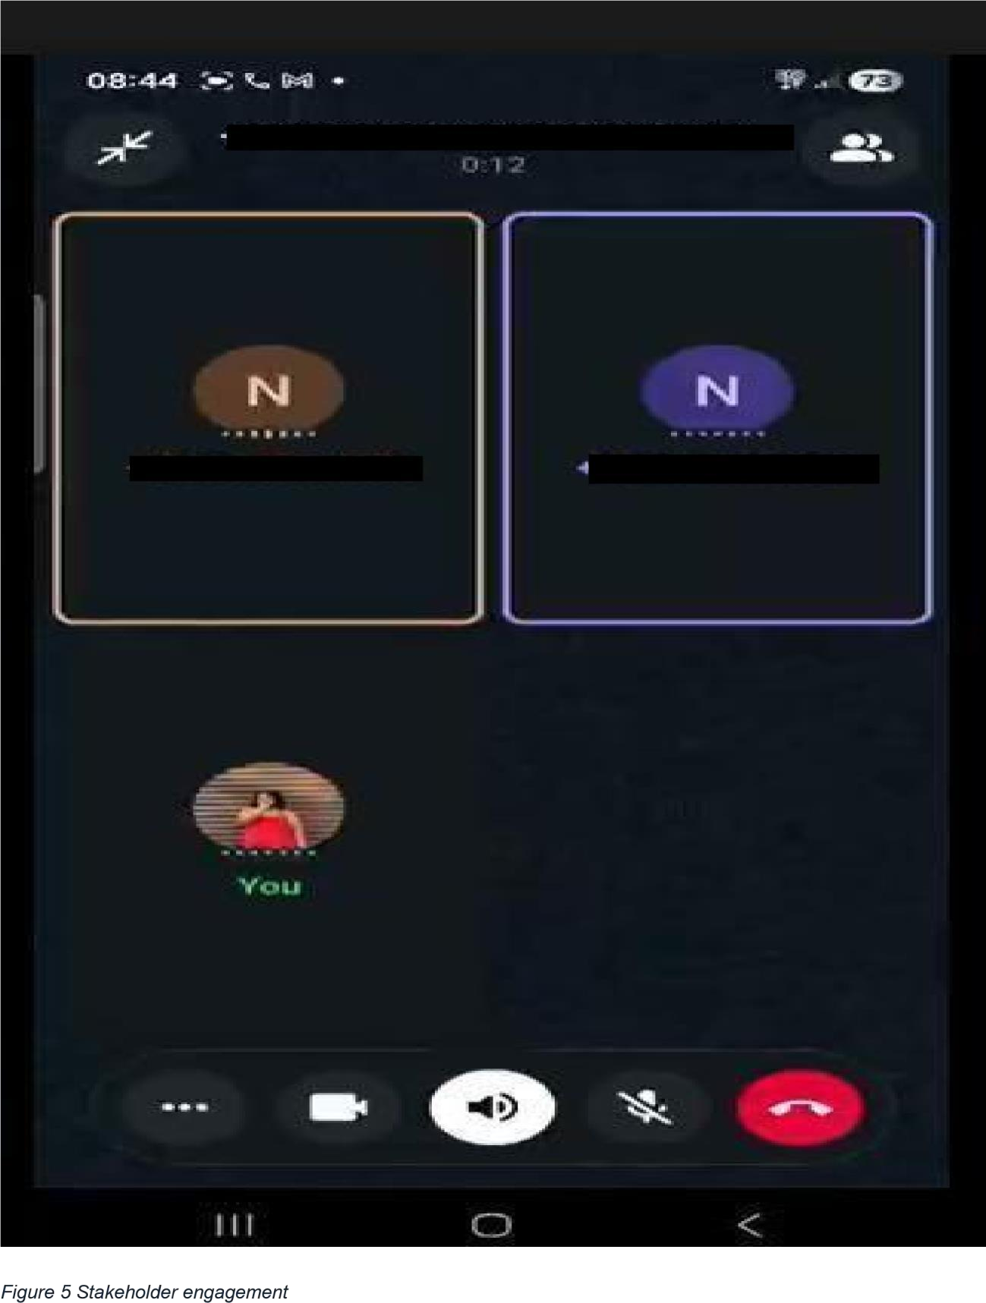

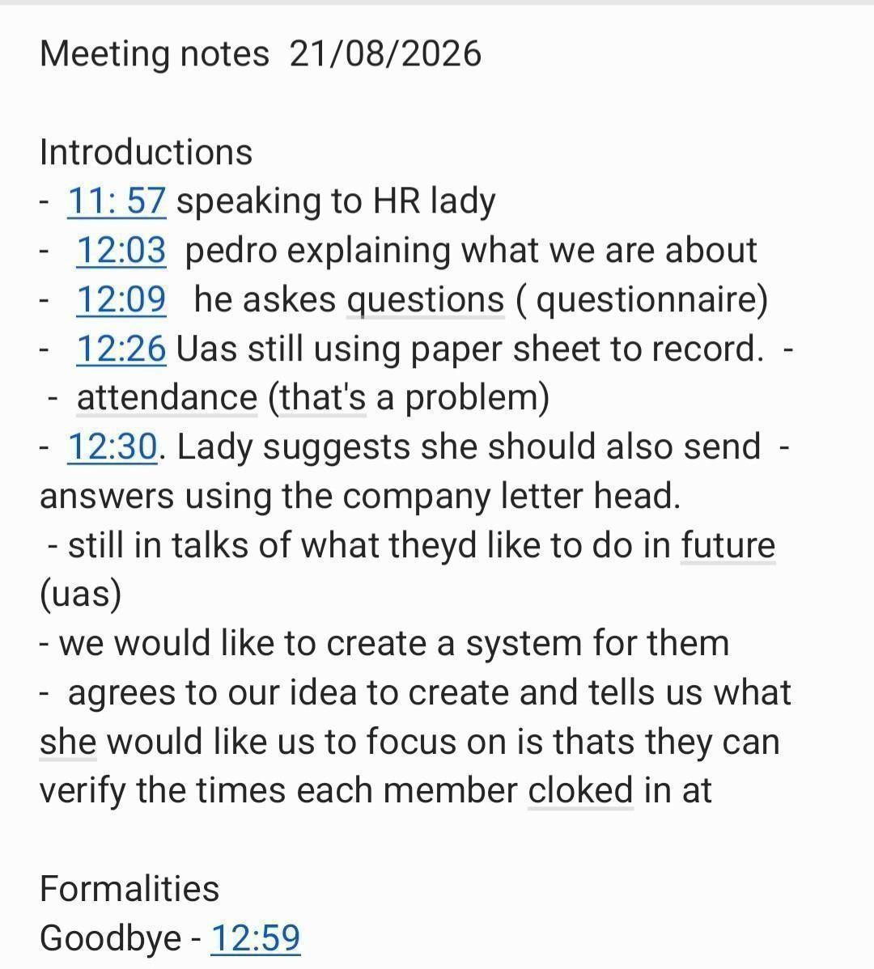 Figure
6 meeting minutes

PHASE 2
────────────────

2. New chapter: System Architecture and Design

2.1 Introduction to System Design
The purpose of this chapter is to present the proposed system architecture and design for the Sebenza Clocking System. The design translates the requirements identified during Phase 1 into a structured technical solution that demonstrates how the proposed system will operate.
The system is intended to replace the organisation’s current manual attendancerecording process with a digital solution for recording employee clockin and clock-out times, calculating working hours and managing overtime. The design consists of a Flutter mobile application for employees, an ASP.NET web application for authorised administrative and supervisory users, and Supabase as the shared backend platform.
The chapter presents the system architecture, UML diagrams, database design and user interface designs. These artefacts are intended to provide a consistent blueprint for the development and testing activities in the next phase.

2.2 System Architecture

2.2.1 Architecture overview
The Sebenza Clocking System will use a multi-component architecture comprising a mobile application, a web application, a backend/API and a shared database and authentication service.

Figure 2.1: Proposed system architecture for the Sebenza Clocking System
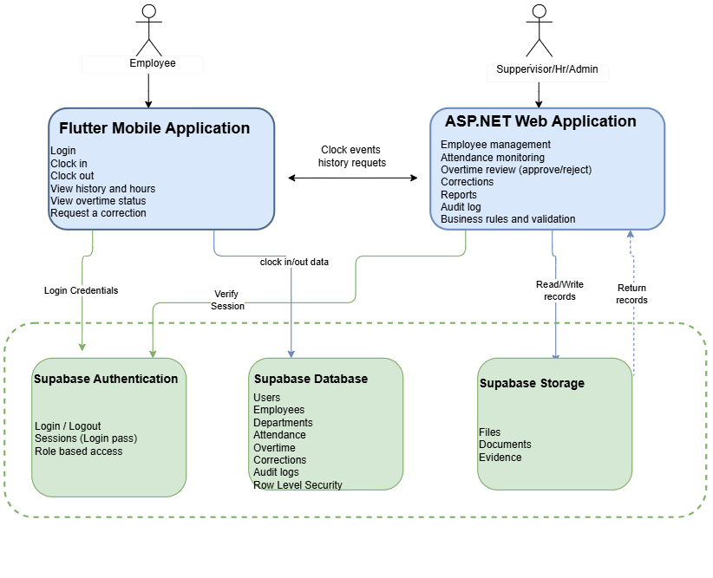
Figure 1 System Architecture

2.2.2 Architecture components and responsibilities

Components | Responsibilities
Flutter mobile application | Provides the employee interface for login, clocking in and out, view history and hours, view overtime status and requesting corrections.
ASP.NET web application | Provides the management interface for monitoring attendance and reviewing overtime requests, reports and audit logs.
Supabase Authentication | Supports role-based access and session management.
Supabase Database | Stores employee, attendance and overtime information, along with relevant audit information.
The components are designed to work together rather than as separate standalone applications. Employees use mobile applications to submit attendance events. Authorised supervisors use the web application to view relevant records and process overtime decisions. The backend and database services support the shared data requirements of both interfaces.

2.2.3 How the components work together
When an employee opens the Flutter mobile application, the system first requires authentication. Once the employee is authenticated, the application can provide access to the functions permitted for that user.
When an employee selects the clock-in or clock-out action, the application sends the attendance request to the system’s backend. The backend validates the request and applies the appropriate attendance rules. The event is then stored in the shared database with a system-generated date and time. The application can subsequently retrieve the employee’s attendance information for display.
For management functions, an authorised supervisor uses the ASP.NET web application. The application checks the user's authenticated session and role before providing access to the overtime review functionality. It retrieves relevant pending overtime records and allows the supervisor to approve or reject a request, with a comment where required. The decision and associated audit information are then stored in the database.
The shared backend enables mobile and web applications to use consistent attendance and overtime information. Access to sensitive records must be restricted according to the user's role and the organisation's approved access rules.

2.2.4 Architecture design decisions
The proposed architecture uses Flutter for the mobile interface because the project requires an employee-facing application that can be used on supported mobile devices. ASP.NET is proposed for the server-side and management functions, while Supabase provides authentication and relational data storage.
The separation of responsibilities is intended to make the system easier to maintain and test. For example, the user interface is responsible for displaying information and collecting user actions, while the backend is responsible for validating requests and enforcing business rules. The database provides persistent storage for the system's records.
The architecture remains a proposed design. During implementation, the group will need to confirm the exact communication method between Flutter, ASP.NET and Supabase, including how authentication tokens and database permissions will be handled.

2.2.5 The main data flow

- Employee → Flutter App: Login details, clock in/out actions, overtime requests, correction requests
- Supervisor/HR/Admin → ASP.NET App: Login details, overtime approvals/rejections, employee management actions.
- Flutter App ↔ Supabase Auth: Login credentials sent, session token returned.
- Flutter App ↔ Supabase Database: Clock in/out data sent, attendance history and working hours returned.
- ASP.NET App ↔ Supabase Auth: Session and role verification.
- ASP.NET App ↔ Supabase Database: Read/write requests for attendance, overtime, and employee records.
- ASP.NET App ↔ Supabase Storage: Upload and retrieval of files and documents.
- Flutter App ↔ ASP.NET App: Clock events and history requests exchanged to keep both interfaces consistent.

2.3.1 Use Case Diagram Overview
The Use Case Diagram presents the main interactions between the users of the Sebenza Clocking System and the system's functions. The diagram identifies the main user roles and the functions available to each role.

Figure
2 Use Case

Components
- Employee
- Supervisor/Management
- Administrator
- Sebenza Clocking System
- Use cases such as Login, Clock In, Clock Out, View Attendance History, View Working Hours, Monitor Attendance, Review Overtime, etc.
How the Components Work Together
Explain which actor performs which function and how <<include>> and <<extend>> relationships are used.
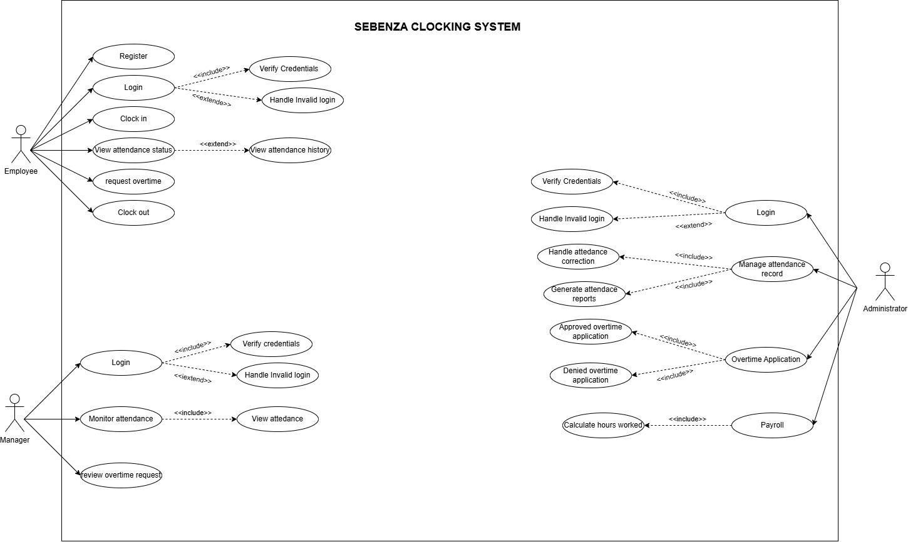
The Phase 2 brief specifically requires the system boundary, actors, use cases, associations and appropriate UML relationships.

2.4 Sequence Diagram — Employee Clock-In

2.4.1 Employee Clock In Overview
The Employee Clock-In Sequence Diagram illustrates the process followed when an employee clocks in using the Sebenza Clocking System. It shows the interaction between the employee, the Flutter mobile application and the backend services involved in processing and storing the clock-in information.
The diagram demonstrates the sequence of requests and responses required to record an employee's attendance.
Figure 2.4: Employee Clock-In Sequence Diagram

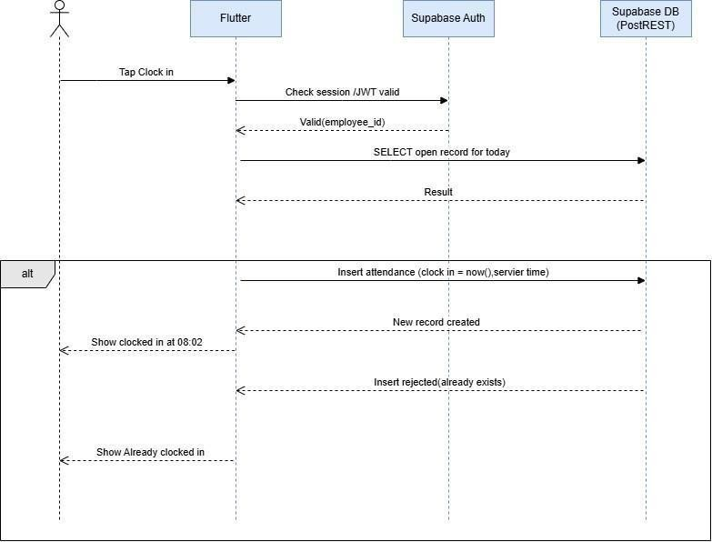
Figure 3 Clock n sequence diagram
(flutter)

Explanation
The Employee Clock-In sequence diagram represents the process followed when an employee records their arrival.
The employee interacts with the Flutter mobile application to initiate the clock-in process. The application communicates with the relevant backend services to authenticate and process the request. The system records the clock-in event using an automatically generated timestamp and stores the attendance information in the shared backend.

2.5 Sequence Diagram — Overtime

2.5.1 Overtime Sequence Diagram — Overview
The Overtime Review Sequence Diagram illustrates the process followed when authorised management reviews an employee's overtime information. It shows how the management user interacts with the ASP.NET web application and how the application communicates with the backend database to retrieve and update overtime information.
Figure 2.5: Overtime Review Sequence Diagram

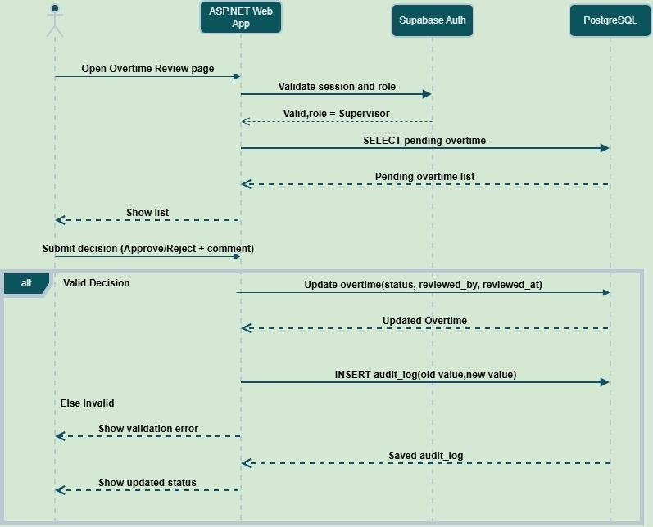
Figure 4 Overtime sequence diagram (ASP.NET)

Explanation
The Overtime Review sequence diagram represents the process followed by a supervisor when reviewing an employee's overtime record.
The supervisor accesses the overtime review function through the ASP.NET web application. The system validates the supervisor's session and role before retrieving pending overtime records.

3. DATABASE DESIGN: ENTITY RELATIONSHIP DIAGRAM (ERD)
3.1 ERD Overview

The Entity Relationship Diagram (ERD) shows how the Sebenza Clocking System organises its data in the Supabase database. The design is centered on the Employees table, which links to all other tables in the system. This structure ensures that every action in the system (clocking in, requesting overtime, correcting records) is tied to a known employee.

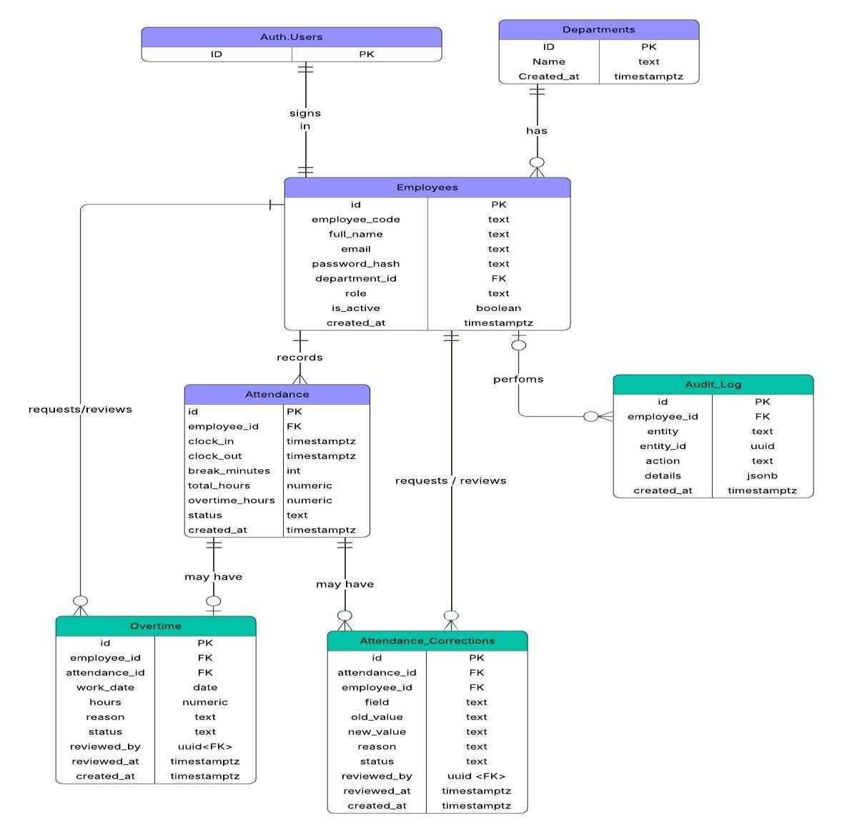 Figure 5
Entity Relationship Diagram

2.6.3 Entity and Attributes table
Entity | Key Attributes | Primary  Key | Foreign key
Departments | D, Name, Created at | ID | -
Employees | id, employee_code, full_name, email, password_hash, department_id, role, is_active, created_at | Id | department_id →  Departments.ID
Attendance | id, employee_id, clock_in, clock_out, break_minutes, total_hours, overtime_hours, status, created_at | id | employee_id →  Employees.id
Overtime | id, employee_id, attendance_id, work_date, hours, reason, status, reviewed_by, reviewed_at, created_at | id | employee_id → Employees.id; attendance_id → Attendance.id; reviewed_by → Employees.id
Attendance  Corrections | id, attendance_id, employee_id, field,  old_value, new_value, reason, status, reviewed_by, reviewed_at, created_at | id | attendance_id → Attendance.id; employee_id → Employees.id; reviewed_by → Employees.id
Audit Log | id, actor_id, entity, entity_id, action, details, created_at | id | actor_id →  Employees.id

2.6.4 Relationship Table
Relationship | Cardinality
Department To Employees | 1:m
Employees to Attendance | 1:m
Employees to Overtime | 1:m
Attendance to Overtime | 1:m
Attendance to Attendance
Corrections

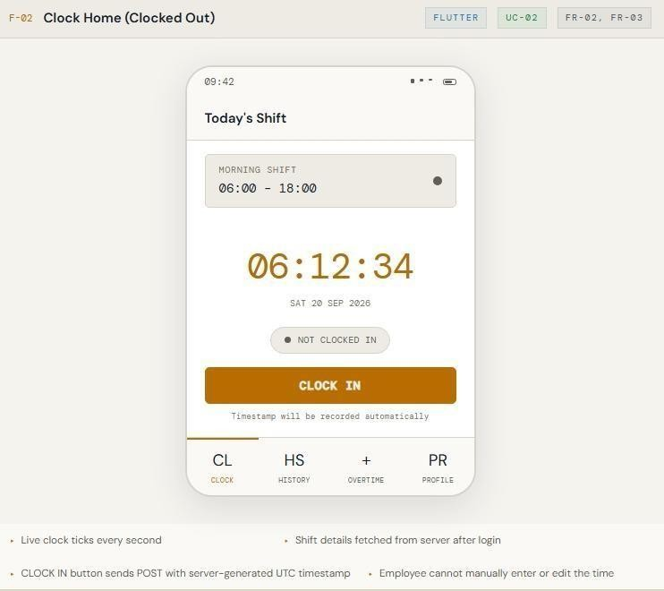

4. USER INTERFACE DESIGN AND DESIGN ALIGNMENT
main Flutter mobile screens

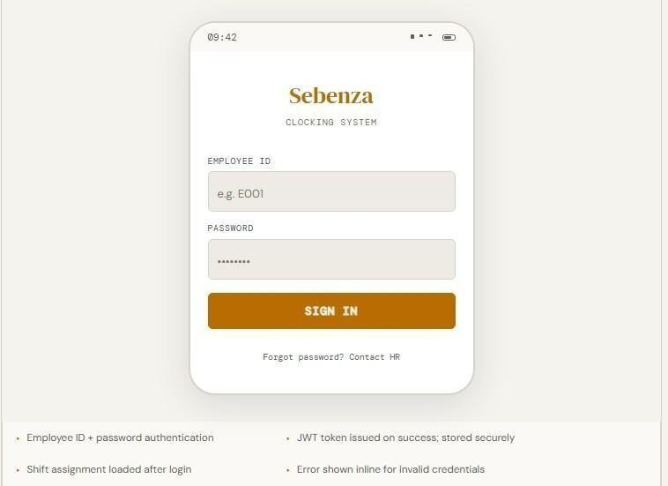 Employee clocks in and out and
Employee enters credentials to access views current shift the system

Employee can view their profile and update details Employee views their past attendance records breaks

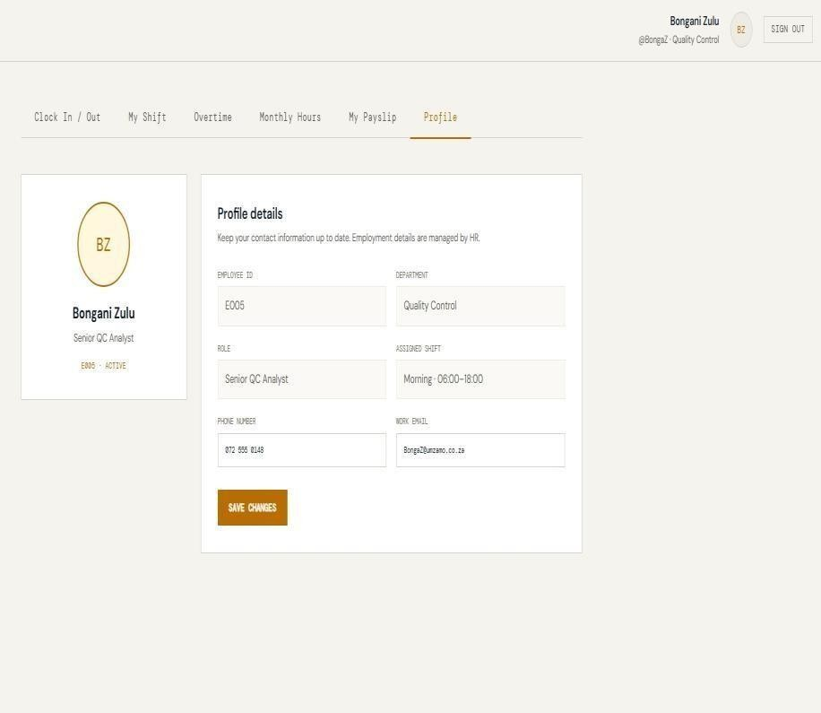
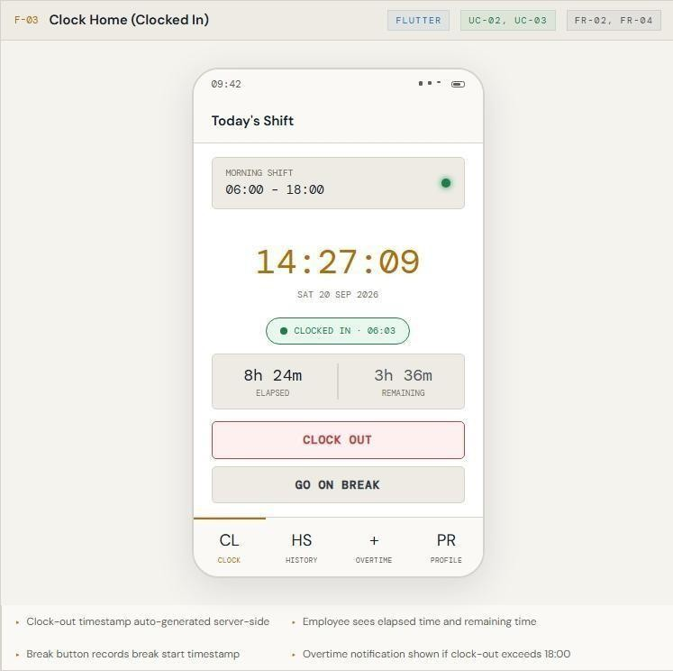

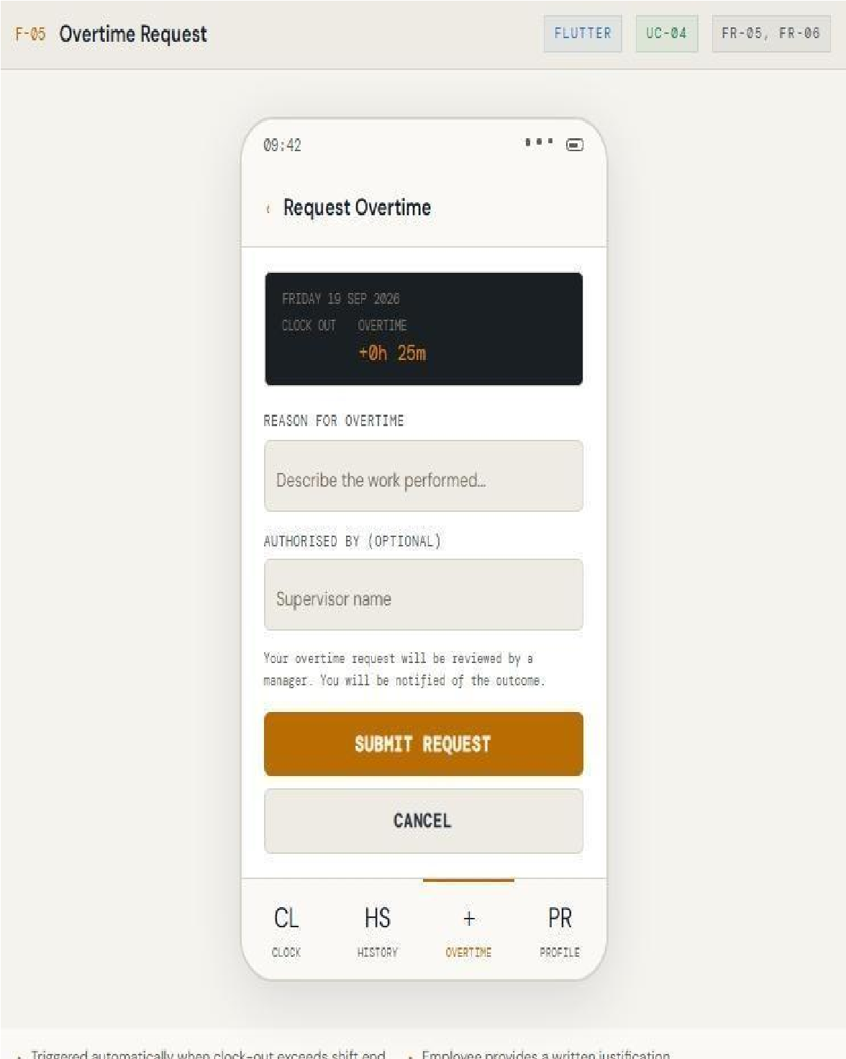
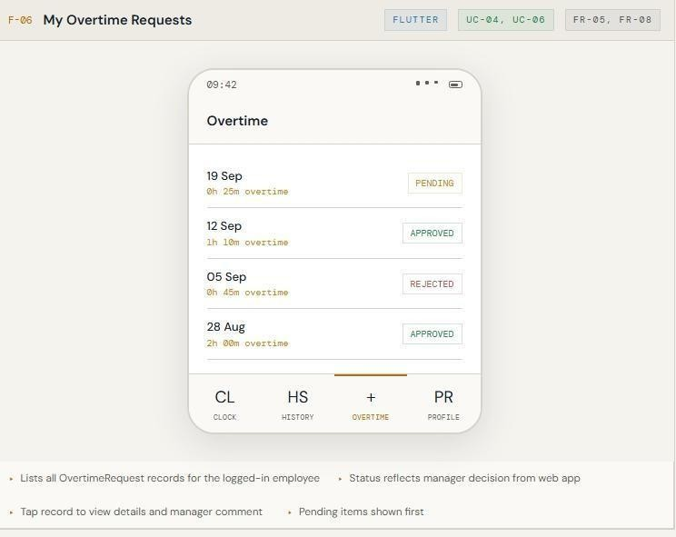

Employee can request for overtime Employee submits an overtime request

How users navigate between important flutter screens

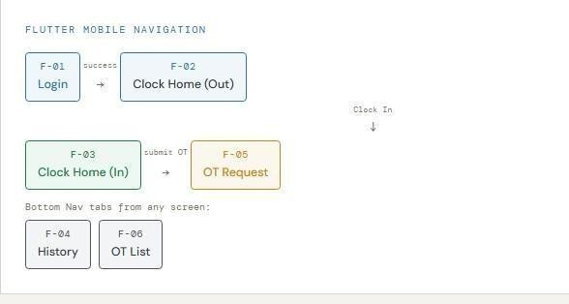
- F-01 Login → Employee logs in
- F-02 Clock Home (Out) → Lands on the clock screen (clocked out state)
- F-03 Clock Home (In) → After clocking in, the same screen changes to clocked in state 4. F-05
OT Request → Employee submits an overtime request

From any screen, the employee can tap these two tabs

- F-04 History — view attendance history
- F-06 OT List — view overtime list/status

main ASP.NET web pages

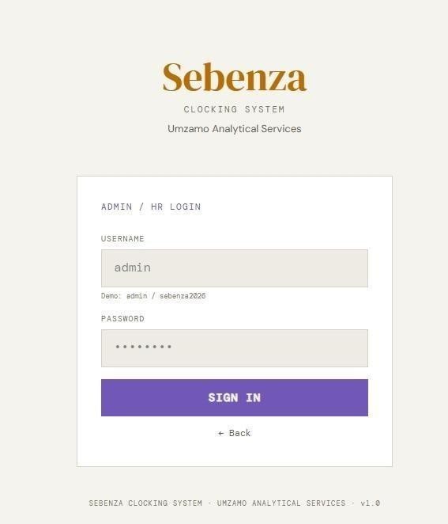
The Admin Login page allows authorised management users(supervisors, HR ,and administrators) to sign in using a username and password

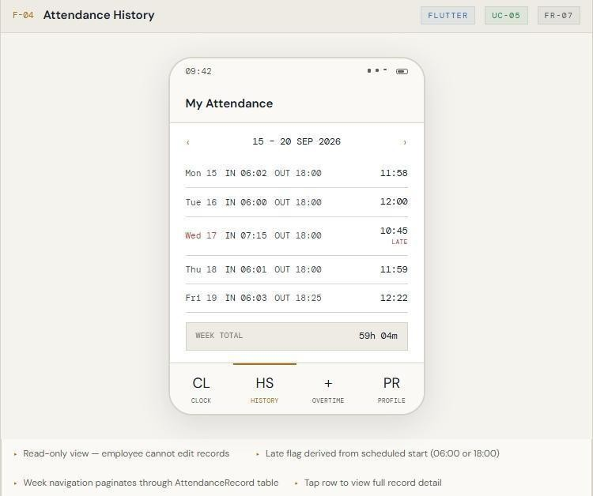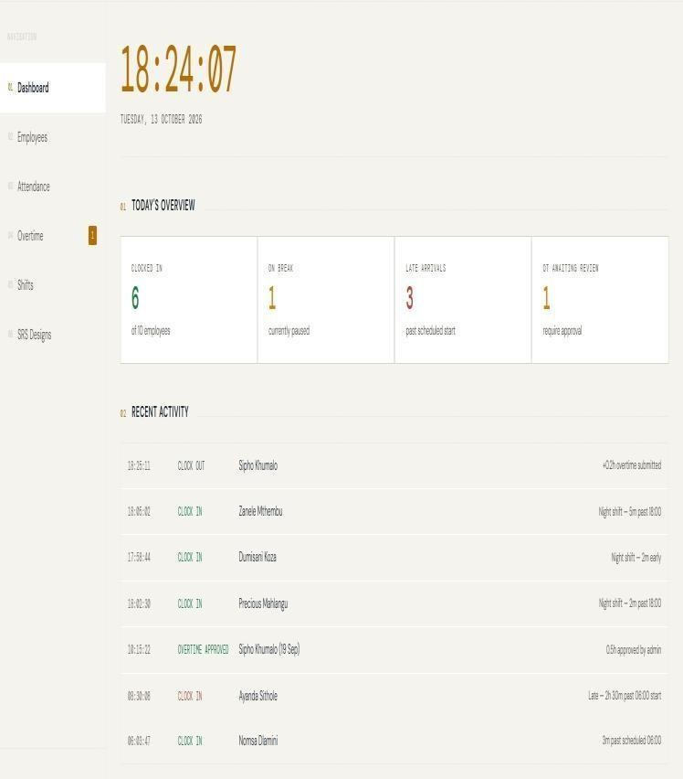

The weekly list of the employee’s clock-in and clock-out times A live feed of the latest attendance and overtime events first.
with hours worked per day. Late days are flagged, using the scheduled start of 06:00 or 18:00, and a week total is shown.
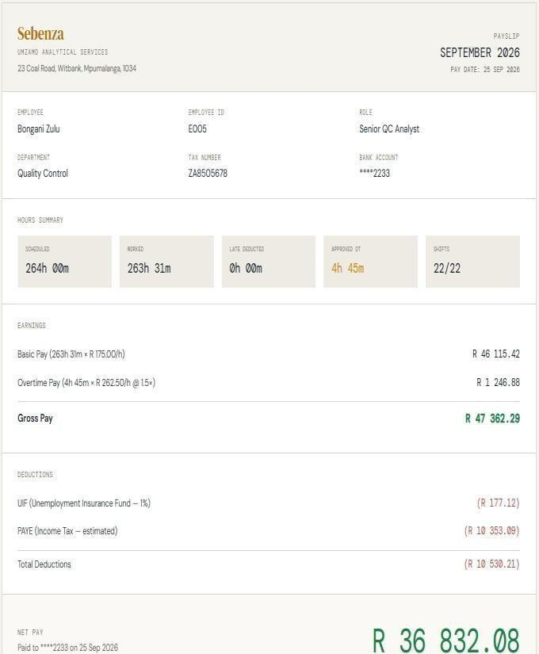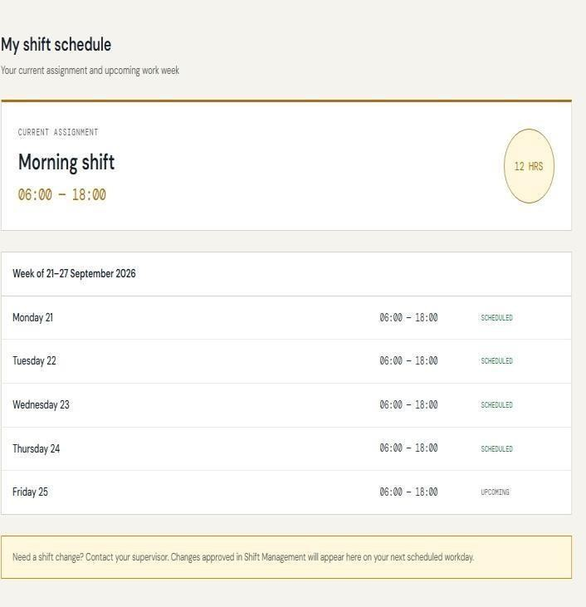
Shows employees monthly hours worked hours and overtime Show shifts for upcoming days
Also shows what the expected income at the end of the month will be

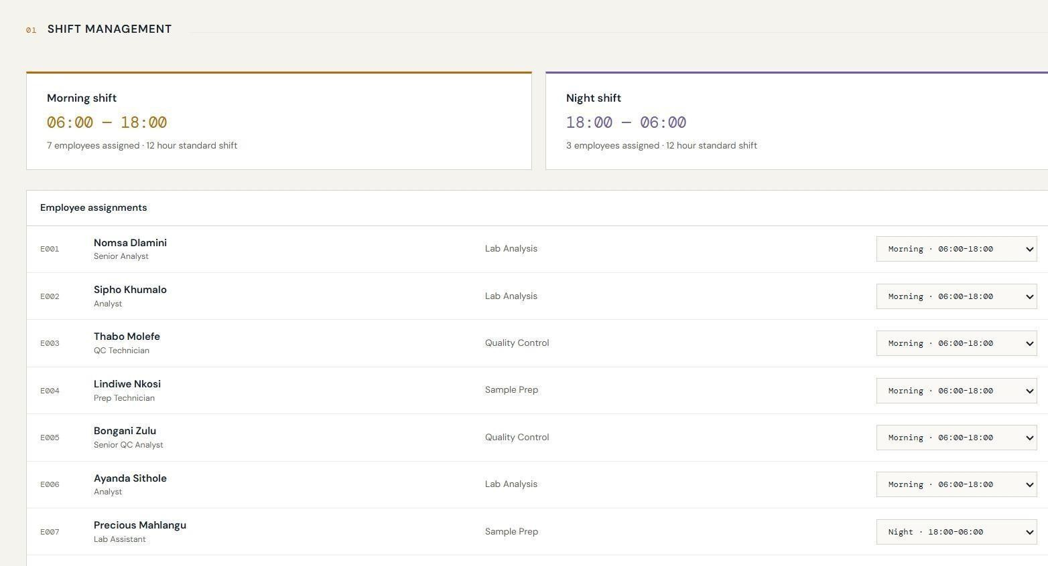
Summary card for Morning(06:00-18:00) and Night
(18:0006:00) with headcounts and a table of employees lets the admin change each’s person assigned shift via drop box.

How users navigate between important ASP.NET screens

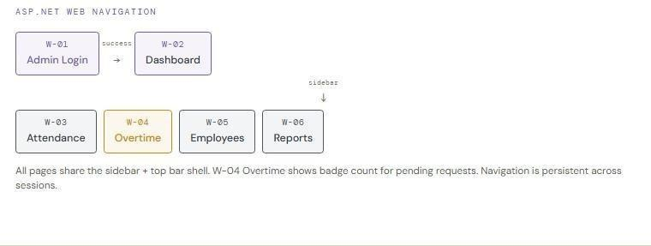

5 Design Alignment Across the designs
Requirement |  | Sequence | ERD element | Flutter interface | ASP.NET  interface
Requirement | Use Case
FR1 Login | Login | Both  sequences validate authenticated sessions | Employees / Supabase  Auth | Login | Login
FR2 Clock In | Clock In | Employee  Clock-In | Attendance | Clock Home | -
FR3  Automatic clock-in time | Clock In | Employee  Clock-In | Attendance.clock_in | Clock Home | -

FR4 Clock  Out | Clock Out | - | Attendance | Clock Home | -
FR5  Automatic clock-out time | Clock Out | - | Attendance.clock_out | Clock Home | -

FR6  Attendance  history | View  Attendance  History | - | Attendance | History | Attendance  Records
FR14 Break recording | Clock in /  Clock Out | - | Attendance.break_minutes | Clock Home | -
FR7 Working  hours | View  Working  Hours | - | Attendance.total_hours | Working Hours | Reports /  Attendance
FR8 Monitor attendance | Monitor  Attendance | - | Attendance + Employees | - | Attendance  Records /  Dashboard
FR9  Overtime | Submit /  Review  Overtime | Overtime  Review | Overtime | Overtime  Request / Status | Overtime  Approval
FR10 Employee management | Manage  Employee Information | - | Employees + Departments | - | Employee  Management
Requirement | Use Case | Sequence | ERD element | Flutter interface | ASP.NET  interface
FR11  Attendance  correction | Request  Attendance  Correction | - | Attendance_Corrections | Correction  Request  (Flutter) | Attendance  Records
FR12  Reports | Generate  Reports | - | Attendance + Overtime +  Employees | - | Reports
FR13 Audit  Logging | Monitor  Attendace | - | Audit_Log | - | Attendance  Records

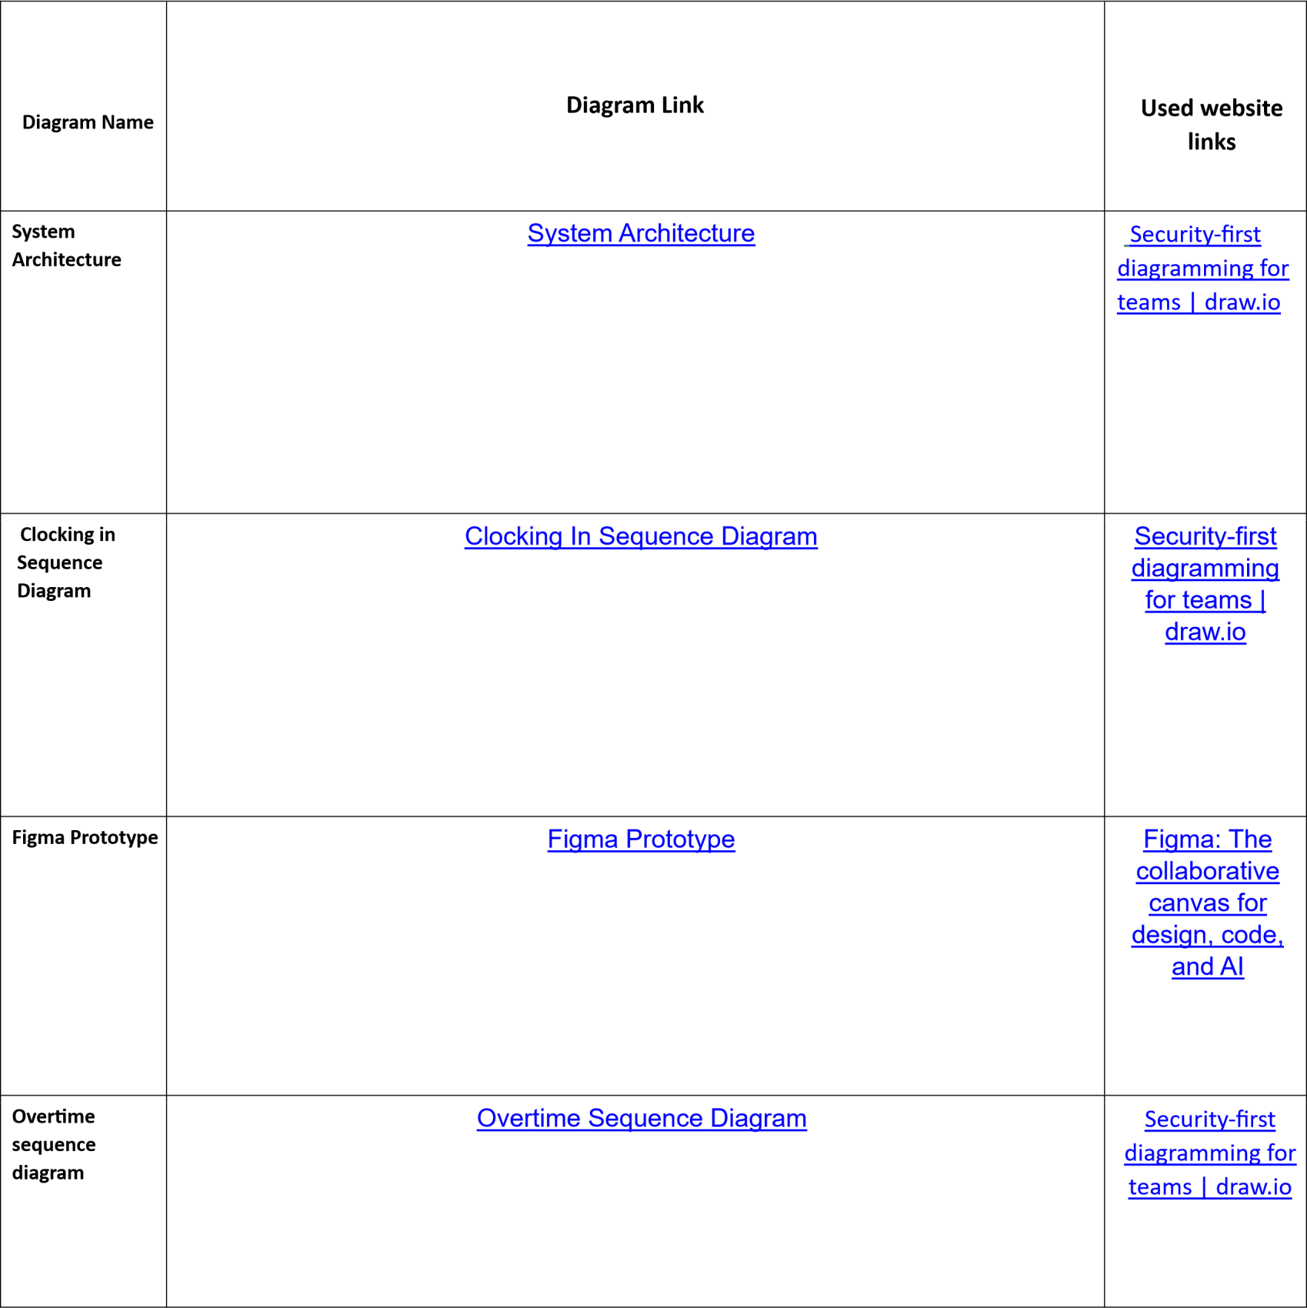
5.1 Diagram Link Table

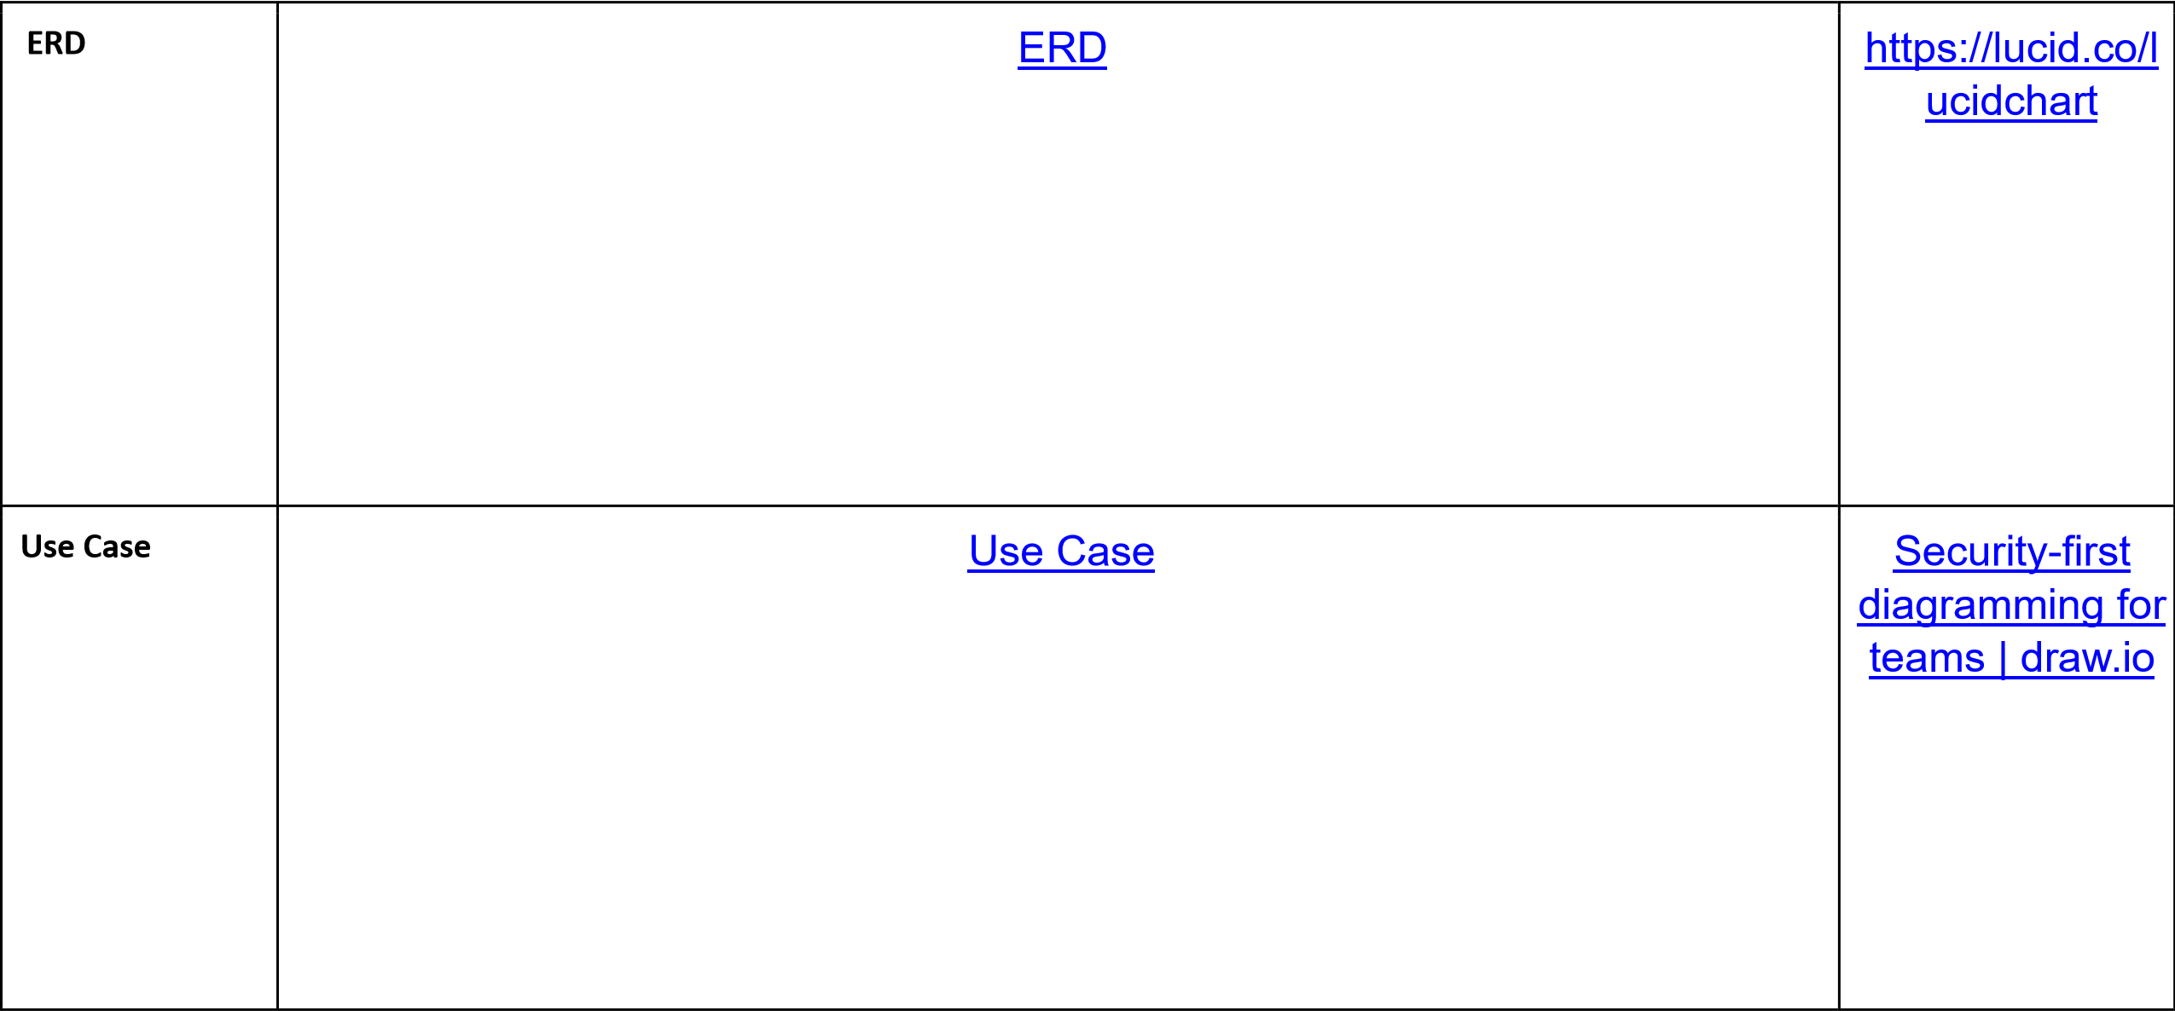
What was shown | Date the proof was obtained | What the stakeholde r said | Changes requested | Changes  Made
System  Architectur e  Diagram,  Use Case Diagram, both  Sequence Diagrams, the ERD and also the figma wireframe s | 9  Septemb er 2026 | Confirmed the diagrams  reflected how attendance and overtime should be handled. Asked for employees to be able to register their own accounts, request corrections  to  attendance records, and request overtime themselves rather than only having it flagged automatically  y. Otherwise satisfied with the designs and open to the group adding further appropriate functionality  . | - Add a registratio n use case/scree n for new  employees  .  - Add a use case/scree  n for  employees to request attendanc  e correction s.  3. Add a  use case  for  employees to request overtime. | Use Case Diagram updated to include Register,  Request Overtime, and correction s related  use cases for the  Employee actor.  Changes completed and  verified by 18  Septemb er 2026.
Stakeholder Feedback

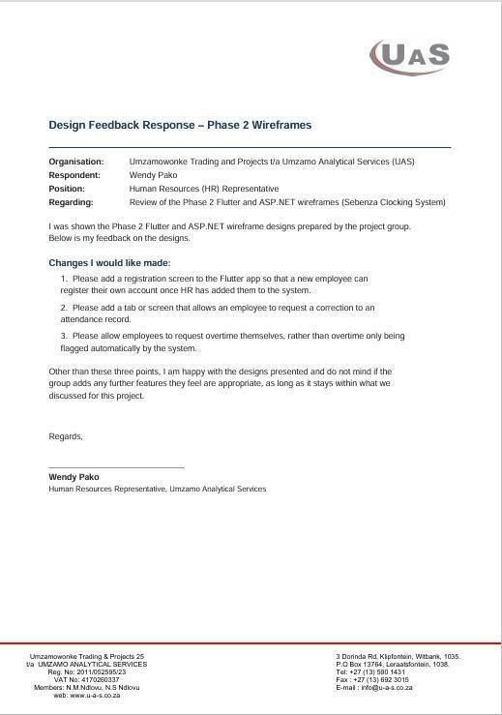
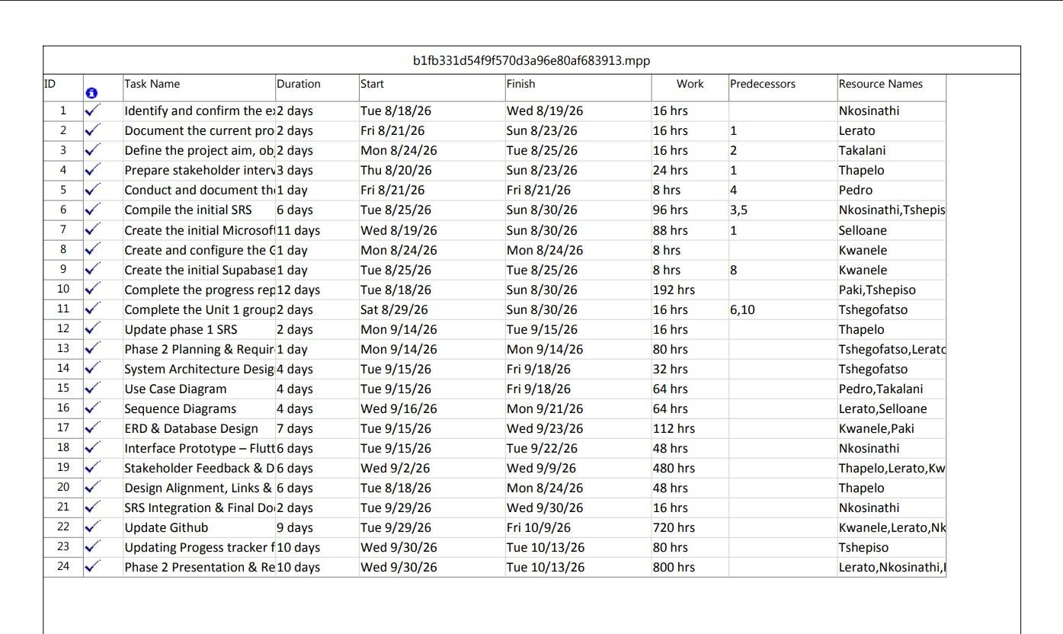
Github repository : https://github.com/biyasekwanele/sebenza-clocking-system

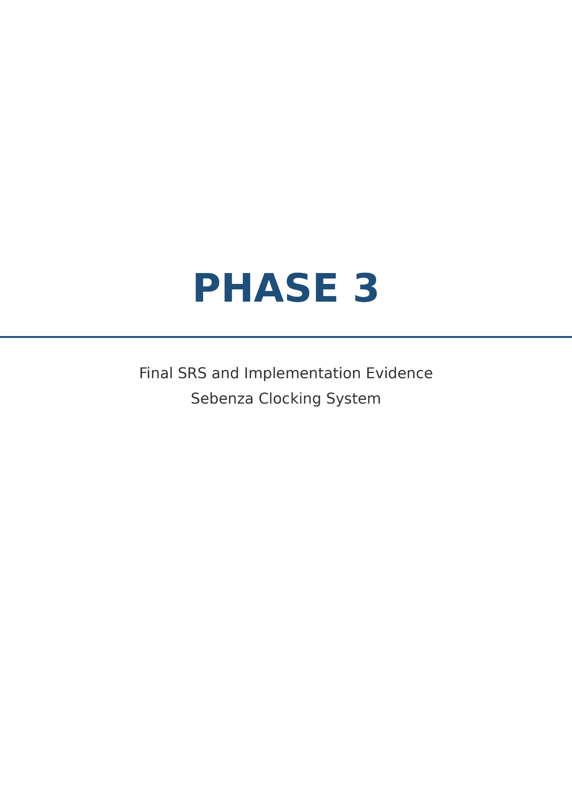

Implementation Overview

The final Sebenza Clocking System prototype implements the core attendance and working-hours functions designed in Phase 2. The system consists of a Flutter mobile application for employees, an ASP.NET web application for authorised management and administrative users, and Supabase as the shared backend platform.

The Flutter application allows employees to log in, clock in and clock out, view attendance history and working hours, submit overtime requests, request attendance corrections, and view the status of their requests.

The ASP.NET application allows authorised supervisors, HR users and administrators to
monitor attendance, review overtime, manage employee information, generate reports, view audit information, and calculate expected monthly income from approved working hours and overtime.

Supabase provides authentication, role-based access support, relational data storage and file storage. The database stores employee, department, attendance, overtime, attendance-correction and audit-log information. Storage is reserved for supporting files such as exported reports and documents related to attendance corrections or overtime approvals.

Implementation approach:
The prototype was developed by connecting the Flutter mobile interface to
the backend services, implementing attendance rules and validation in ASP.NET, and storing shared records in Supabase. The implementation follows the Phase 2 architecture: the employee submits attendance actions through Flutter, authorised management users access and review records through ASP.NET, and both interfaces use the shared Supabase backend.

Implemented Requirements

Requirements | Approved Requirement | Functions | Status
FR1 | Secure login for  authorised users | Flutter employee login and  ASP.NET management login using  Supabase Authentication | Working
FR2 | Employee clock-in | Employee submits a clock-in  request from the Flutter Clock  Home screen | Working
FR3 | Automatic clock-in  timestamp | System records the clock-in date  and time automatically | Working
FR4 | Employee clock-out | Employee submits a clock-out  request from the Flutter Clock  Home screen | Working
FR5 | Automatic clock-out  timestamp | System records the clock-out date  and time automatically | Working
FR6 | Attendance history | Employee views past attendance  records in Flutter | Working
FR7 | Working-hours  calculation | System calculates total working  hours from clock-in and clock-out  times, deducting approved break  time | Incomplete
FR8 | Attendance monitoring | Authorised management users view  employee attendance records in  ASP.NET | Incomplete
FR9 | Overtime management | Employees submit overtime  requests; management reviews and  approves or rejects them | Working
FR10 | Employee  management | Administrators manage employee  information | Incomplete
FR11 | Attendance correction  requests | Employees request corrections;  authorised users review them | Working
FR12 | Reports | Authorised users generate and  export attendance and overtime  reports | Working
FR13 | Audit logging | Changes to attendance, overtime  and employee records are recorded  in the audit log | Incomplete
FR14 | Break recording | Employees record break periods  during a shift | Working
Payroll reporting | Calculate expected  monthly income from  approved working  hours and overtime | ASP.NET calculates expected  monthly income; actual salary  payments are not processed | Incomplete

Screenshots of Approved screens

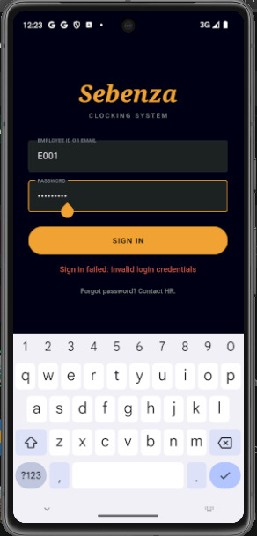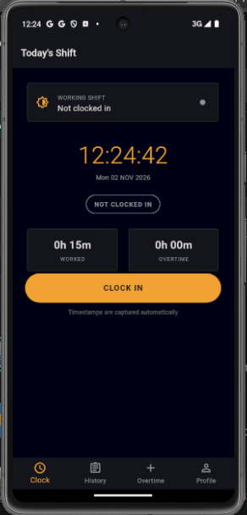

Provide access to the system through Allows employees to record their arrival time
Sign Up for new employee's and log in

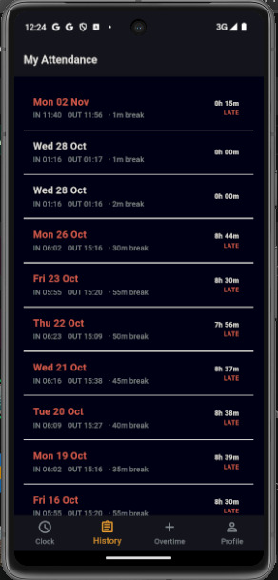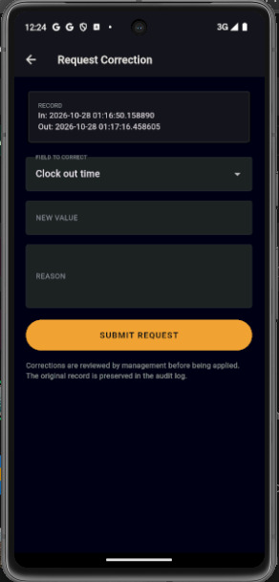

A table listing attendance entries with filters Requests to fix attendance
(date range, department, employee/status) and
columns like date, employee, department,
time in/out, total
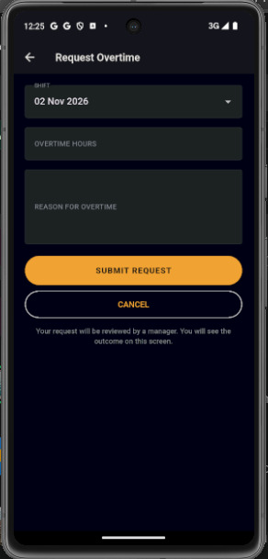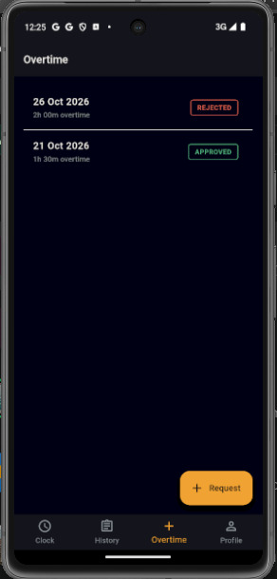

Handles pending overtime requests with Overtime reviewed status (approve/reject shown or implied)

Approve/Reject buttons
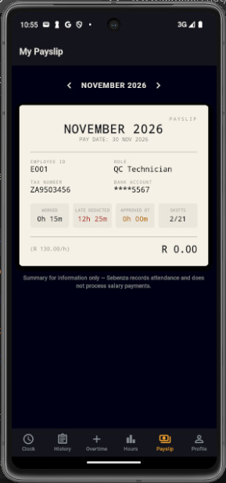
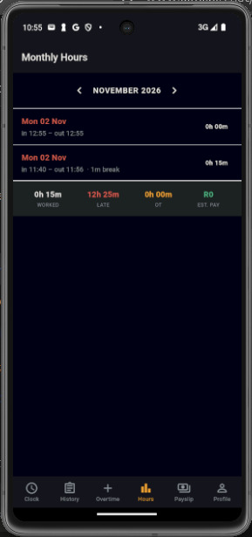
Monthly Payslip
Monthly payment calculated

Changes Made During Implementation

Change | Reason | Impact on design
Added employee  registration screen | Stakeholder feedback requested  that new employees register their  own accounts. | Added a registration use case and Flutter  screen
Added employee  overtime request function | Stakeholder feedback requested  that employees request overtime  themselves | Added overtime request screen and  overtime review workflow
Added attendance  correction request function | Stakeholder feedback requested a  controlled correction process. | Added correction request screen,  database record and review process
Added expected  monthly income calculation | Finance requires accurate  working-hour and overtime  information for payroll use | Added payroll reporting to ASP.NET;  actual salary payment processing  remains out of scope.

Remaining Limitations

- The prototype does not process actual salary payments, tax, deductions or bank transactions; it only calculates expected monthly income from approved working hours and overtime.

- Biometric verification or facial recognition is not implemented
- Offline clocking is not supported when there is no internet connection

Source code area | Location in repository
Flutter mobile application | Sebenzaclocking system repository/mobile-app
ASP.NET web application | Sebenza Clocking system / web-app
Supabase database scripts | Sebenza clocking system / supabase
Documentation | Sebenza Clocking system /docs

Microsoft Project Planner

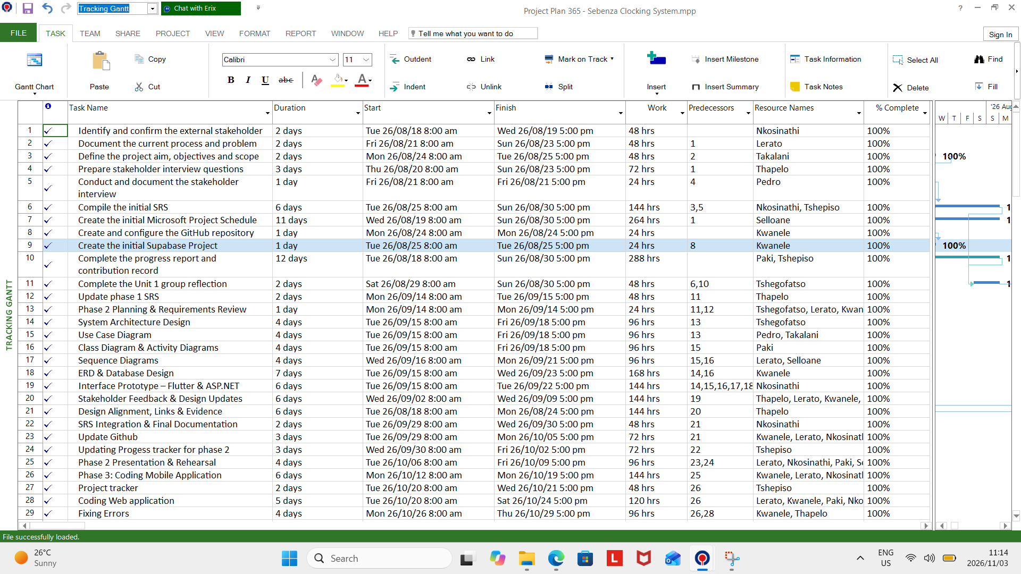
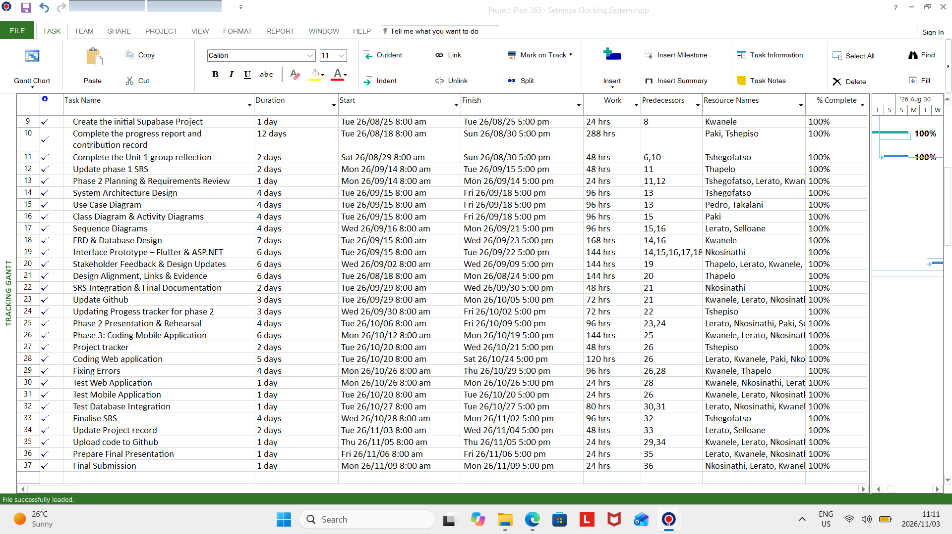

Design Source Links

Github repo : https://github.com/biyasekwanele/sebenza-clocking-system

